Cybersecurity & Network Security
Internship Assessment Report
Tasks Completed: Task 1 & Task 2
Date: 17 April 2026
Language: Python

1. Introduction
This report is about the design, implementation and testing of two cybersecurity systems. These systems were developed as part of the internship assessment. The tasks chosen are::
Task 1. Tamper-Evident Logging System:
A blockchain-inspired audit log. Every entry in this log is cryptographically linked to the one. This makes it impossible to modify reorder entries without detection.

Task 2. Controlled Execution Sandbox:
A Python-based code execution environment. This environment accepts user-supplied scripts while enforcing strict security constraints.

Both implementations are written in Python. They are self-contained and only require the library. Each system has a demonstration harness. This harness exercises both adversarial inputs.

2. Task 1 — Tamper-Evident Logging System

2.1 Design Approach
The tamper-evident log is based on a blockchain. Each entry has a hash of its content and the hash of the previous entry. This chain of hashes makes it hard to alter any entry without invalidating every subsequent one.

The design focuses on three properties:
- Integrity — Any modification to a stored entry is detected during verification.
- Ordering — Deletion or reordering of entries breaks sequence continuity and chain linkage
- Non-repudiation — because every entry is hashed at write time and the hash is stored alongside the entry, and this allows the original content can always be verified against the stored digest.

2.2 Data Structure
Each log entry is a JSON object persisted as a single line in a plain-text file (secure_audit.log). The fields are:

Field | Description
sequence_id | An increasing integer. It detects deletions and reordering.
timestamp | ISO 8601 UTC timestamp at write time.
event_type | A category label (e.g. AUTH, TRANSACTION, SYSTEM).
description | A human- event description.
metadata | A dictionary of extra context (IP amounts, file paths, etc.).
prev_hash | The SHA-256 hash of the entry. For the entry it is GENESIS_HASH.
entry_hash | The SHA-256 of all fields combined (sorted JSON serialization).

2.3 Hashing Algorithm
The entry hash is computed as follows:
payload = json.dumps({all fields except entry_hash} sort_keys=True)

Using sort_keys=True ensures that dictionary fields are always serialized in the order. SHA-256 was chosen for its collision resistance and wide adoption.

2.4 Tamper Detection Mechanism
The verify_log() function checks every stored entry in order and performs three checks:

- Hash integrity — Recomputes entry_hash from stored fields and compares it to the stored value
- Chain linkage — Checks that each entrys prev_hash equals the entry_hash of the preceding entry..
- Sequence continuity — Verifies that sequence_id increments by one between consecutive entries.

A tamper is localised: the verifier reports the index and sequence_id of every affected entry, helping an auditor pinpoint exactly where the log was compromised.

2.5 Implementation Details
The system exposes three public functions:
- add_log(event_type, description, metadata). Appends a new entry. It. Chains hashes automatically.
- verify_log(). Validates the chain. It returns a result dict with valid (bool) total_entries (int) and issues (list).
- display_log() — Prints all entries with truncated hashes for readability.

The log file uses one JSON object per line (JSON Lines format), making it straightforward to append new entries without reading the entire file, and easy to stream-process during verification.

2.6 Analysis of Results
The demonstration harness confirms all three detection capabilities:

- Unmodified log: verify_log() returns valid=True across all 5 entries with no issues reported.
- Tampered log: after falsifying the description of entry #2 and deleting entry #3 the verifier correctly reports issues.
- Restored log: re-adding entries from scratch yields a clean verification, confirming that the mechanism itself is sound.

The system scales linearly with the number of entries. Both. Verify operations are O(n) with a small constant factor dominated by SHA-256 computation.

When we add all the logs in ‘add_logs.py’ file and exit all the logs will be stored in ‘logs.json’ file
after if we verify using ‘python verify.py’ we can see the out put that “No tampering has been detected.

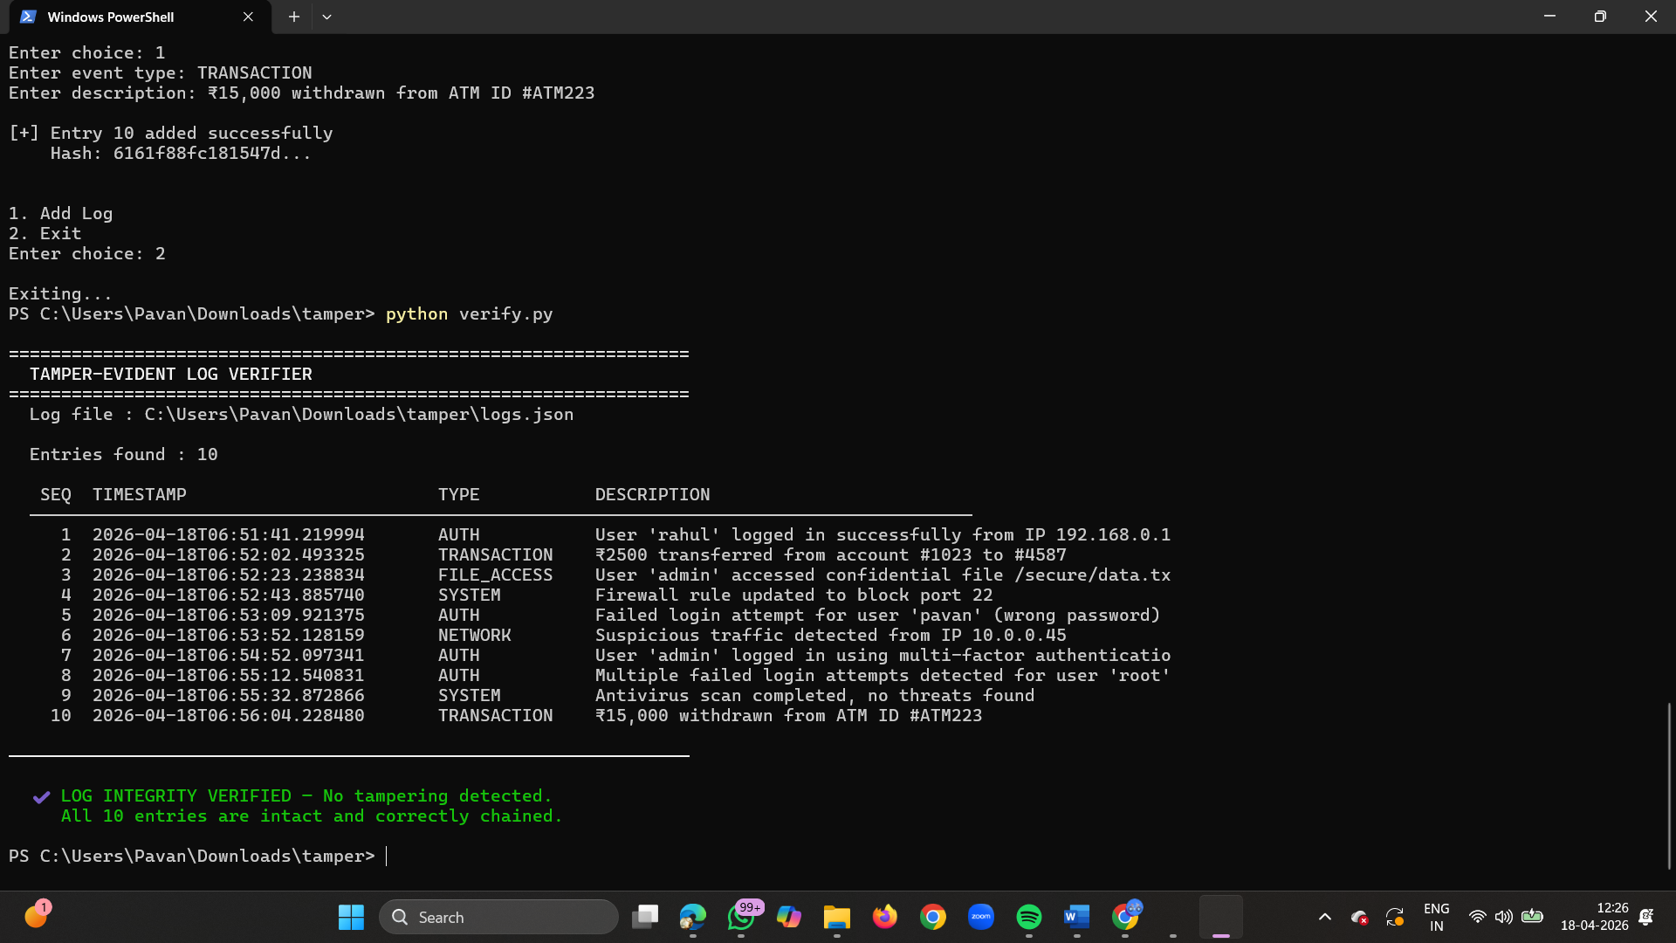
>> when we opened the file and changed or modified the file and after modifying if we check the ‘python verify.py’ we can see the message “Tampering Detected”
